Chapter 5 Electrical physics
Chapter test Total marks 45
Name: Class: Date: __________
Section A (1 mark per question)
Question 1
The lower vertical slot of any power point in your home will enable a connection to which of the following?
A the active part of the supply circuit
B the neutral part of the supply circuit
C the earth wiring in your home
D a fuse
Question 2
Which of the following factors affect the resistance of a conductor?
A length, lustre and temperature
B temperature, density and length
C length, area of cross-section and lustre
D area of cross-section, length and temperature
Question 3
Which of the following is the correct definition for electric current?
A the charge per unit volume per unit time
B the charge per unit volume
C the charge per unit time
D the time per unit charge
Question 4
How does the effective resistance of two identical resistors in parallel (R_{T}) compare to the resistance of each individual resistor (R)?
A RT = R
B RT < R
C RT > R
D It depends on the resistance, R.
Question 5
How much current is drawn by a 6.0 W torch globe that uses two 1.5 V batteries placed in series?
A 0.5 A
B 4.0 A
C 9.0 A
D 2.0 A
Section B
Question 6
A negative charge lies within a uniform electric field of strength 5.00 × 104 N C1 directed up the page. The charge on an electron is −1.60 × 10–19 C.
a Calculate the size of the force acting on the particle. (3 marks)

b Describe the effect of the force on the particle. (2 marks)

Question 7
Describe the energy transformations that occur during the operation of the circuit shown below when the switch is closed. (3 marks)

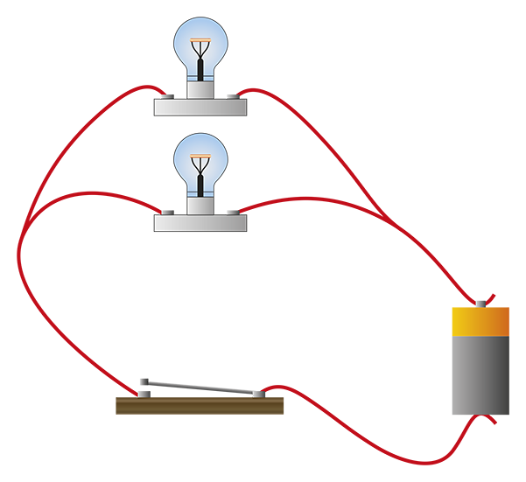

Question 8
a Samantha discovers that the 12.0 V battery in her new car is connected via a switch to
two heater elements (resistors) in parallel, which are used to heat the driver and
passenger seats. Draw a labelled diagram to represent this circuit. (3 marks)

b Thinking that the seats are not heating properly Samantha decides to use a voltmeter to
check the operation of the switch. Draw how she would attach the voltmeter to the
circuit in part a. (2 marks)

c When the switch is open, what value should the voltmeter read? (1 mark)

d When the switch is closed, what value should the voltmeter read? (1 mark)

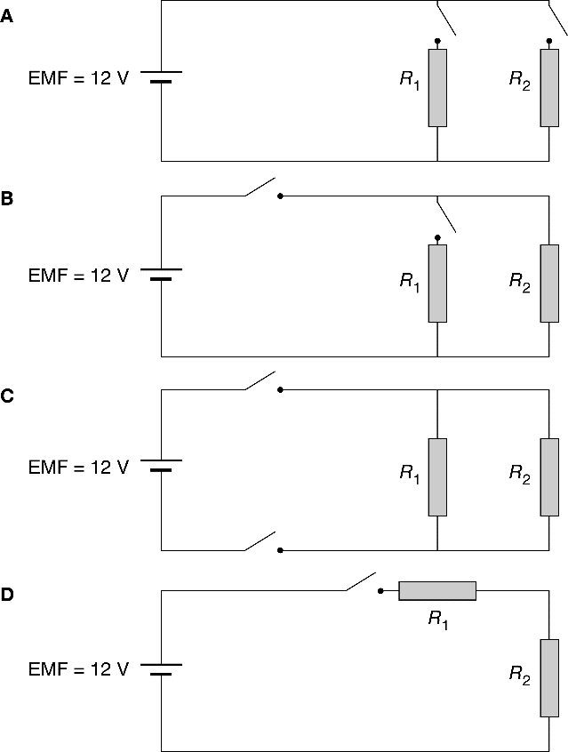
e Samantha takes her car to an auto electrician who rewires the seat heating circuit to allow each seat to be individually heated. Which circuit diagram shows this? (1 mark)

f The resistors are identical and are rated at 300 Ω. What is the total resistance of the
circuit when both seats are heated at the same time? (2 marks)

g What current is drawn when both seats are heated at the same time? (1 mark)

h If this amount of current were to go through a person it would cause serious injury.
Does this mean that the seat warmer elements are potentially dangerous? (1 mark)

Question 9
A battery in a circuit has current of 4.50 A passing through it.
a How many coulombs of charge pass through the battery in 5.00 s? (1 mark)

b If the battery provides a potential difference of 9.00 V, how many joules of energy does it provide to the circuit each second? (2 marks)

Question 10
a How much energy, in kilowatt hours and joules, will a 200 W globe use in 4.00 hours of operation? (2 marks)

b An electricity company charges 60.0 cents per kW h of electricity consumed. How much does it cost to use this 200 W globe for one hour? (2 marks)

Question 11
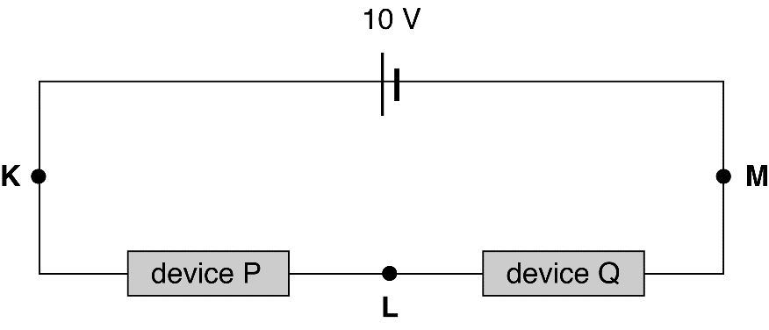
Two electrical devices are connected in a series circuit as shown in the following diagram. The battery has zero internal resistance and the current at point K is 100 mA.

a What is the current at point L? (2 marks)

The current–voltage characteristics for these two devices are shown in the graphs below.

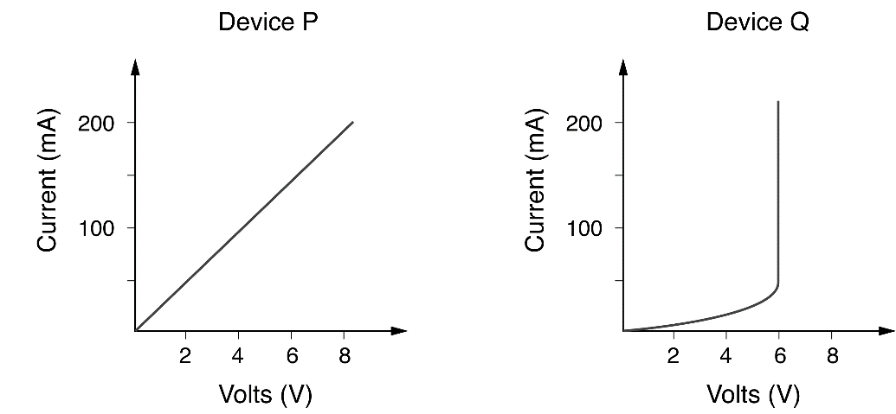

b Calculate the potential difference between points K and L. (2 marks)

c Calculate the potential difference between points L and M. (2 marks)

d What is the effective resistance of device Q in this situation? (2 marks)

e Which of these two components obeys Ohm’s law? (1 mark)

f Determine the resistance of the device you identified as ohmic in part a. (2 marks)

g What is the effective resistance of the other device when a current of 200 mA flows
through it? Why is this not a useful quantity? (2 marks)

